Internal Audit System (IAS)
User Manual
Practical screen and workflow guide
Document version 2.0 | 28 August 2026
Prepared from the verified IAS source tree and the authenticated local application views. No credentials, secrets or live record details are included.

Document Control
Document | IAS Software User Manual
Version | 2.0
Date | 28 August 2026
Status | Issued for operational use and review
Basis | All 19 supplied roles verified in the authenticated UI and cross-checked against IAS authorization/menu source

Revision History
Version | Date | Prepared for | Change
2.0 | 28 Aug 2026 | IAS users / IT review | Complete 19-role UI verification, permission matrix and discrepancy register

How to Use This Manual
IAS menus and actions are permission-based. A screen may be absent, read-only or show different workflow actions for another user. Follow the controls actually displayed for your signed-in profile. Empty screenshots indicate that no test records were available; they still verify the screen layout and available controls.

Table of Contents

In Microsoft Word, right-click the table and choose Update Field if page numbers are not refreshed automatically.

1. Getting Started

1.1 Sign in
Open the IAS address supplied by your organization. Enter your assigned user name and password, then select the login action. If IAS reports an existing session, follow the on-screen session message or contact the system administrator. Never share credentials or include them in screenshots.

1.2 Navigation and access
After sign-in, the left navigation groups functions into Dashboard, Planning, Engagement, Execution, Auditee Portal, Post Compliance, I&ID, Reports, FAD, CAU, Sampling, Setup, Admin and Email. Use the menu collapse control when more space is required. Use Logout when work is complete.

1.3 Common list and form behaviour
- Choose parent filters first; later lists often remain empty until a required entity, period or engagement is selected.
- Review the record status before using a row action.
- Save preserves entered work where the screen provides it; Submit, Approve, Reject, Authorize or Finalize moves or decides workflow work and should be used only after review.
- Search filters the current list. PDF, Excel, CSV, Print or Download actions create the output named on the screen.
- For evidence uploads, choose only the requested business file, confirm the correct record, and use the upload action displayed. Open or download evidence through the record-specific retrieval action.

2. Home and Dashboard
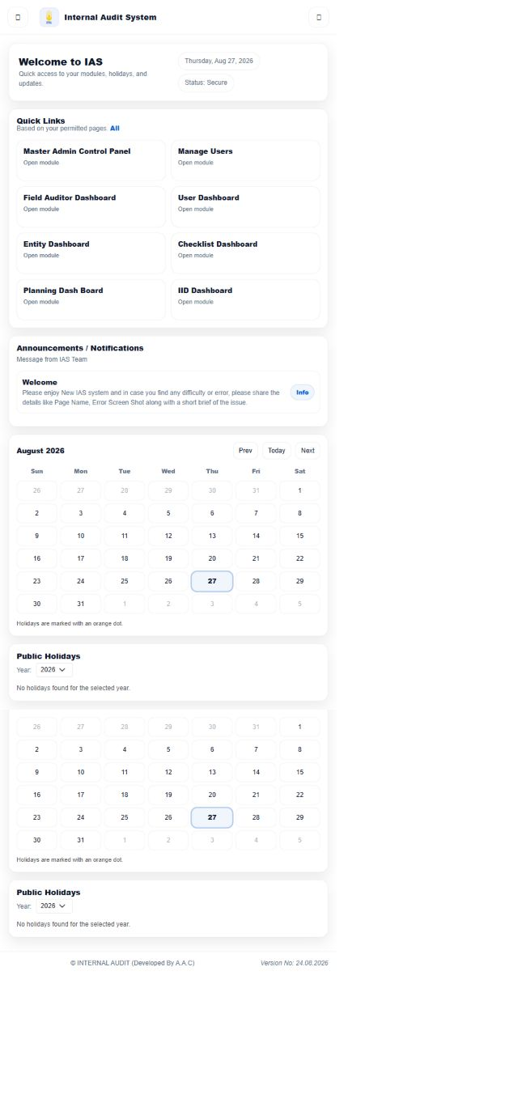
Figure 2.1: IAS Home and dashboard workspace
The home workspace provides quick links, announcements, calendars/holidays and dashboard entry points available to the signed-in user. Select a quick link or expand a module in the left menu. The verified home view exposed Master Admin Control Panel, Manage Users, Field Auditor Dashboard, User Dashboard, Entity Dashboard, Checklist Dashboard, Planning Dashboard and IID Dashboard for the reviewed profile.
Typical path: Login → Home → select a module → choose a record → complete the displayed action → verify status or output.

3. Planning

3.1 Audit Criteria
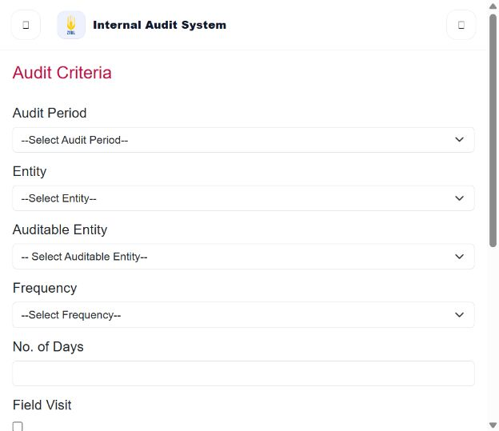
Figure 3.1: Audit Criteria
Purpose: Define an audit period, entity, auditable entity, frequency, duration and field-visit requirement before submitting criteria.
Access: Users whose IAS page/menu permissions expose this screen. Review/approval/administration actions additionally depend on the actions enabled for the signed-in profile.
Main fields and controls: Audit Period, Entity, Auditable Entity, Frequency, No. of Days, Field Visit, Save, Delete and Submit.

Procedure
- Open Planning > Audit Criteria.
- Select the audit period and entity.
- Select the auditable entity and frequency.
- Enter the number of days and set Field Visit when applicable.
- Select Save and review the new row in the criteria table.
- Use Delete only for an incorrect saved row; select Submit when the displayed criteria are ready for the next stage.
Expected result: IAS stores the criteria row and, on Submit, sends the displayed criteria into the configured planning review flow.

4. Engagement

4.1 Engagement Plan List
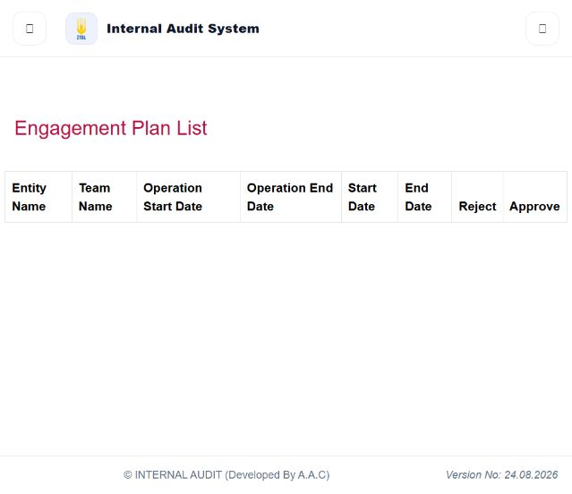
Figure 4.1: Engagement Plan List
Purpose: Review engagement dates and make the available approve or reject decision.
Access: Users whose IAS page/menu permissions expose this screen. Review/approval/administration actions additionally depend on the actions enabled for the signed-in profile.
Main fields and controls: Entity Name, Team Name, operation/start/end dates, Reject and Approve.

Procedure
- Open Engagement > Engagement Plan List.
- Locate the engagement row and compare the entity, team and displayed dates.
- Choose Approve or Reject from the row when that action is available to your profile.
- Confirm the resulting status or removal from the work list.
Expected result: The selected engagement decision is recorded and the work list refreshes.

5. Execution

5.1 Manage Observations
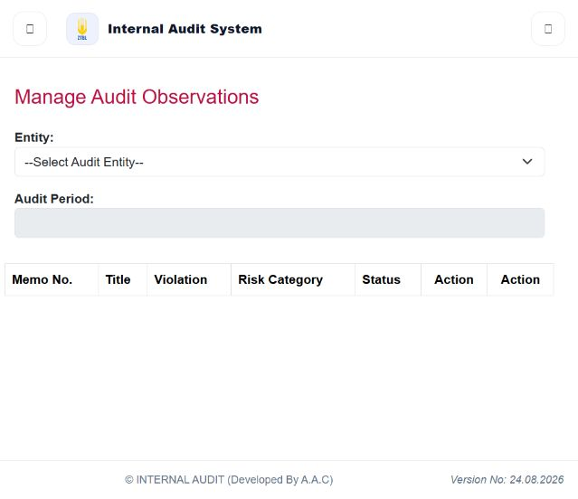
Figure 5.1: Manage Observations
Purpose: Select an audit entity and period, then review and act on the resulting observation list.
Access: Users whose IAS page/menu permissions expose this screen. Review/approval/administration actions additionally depend on the actions enabled for the signed-in profile.
Main fields and controls: Entity, Audit Period and a table containing Memo No., Title, Violation, Risk Category, Status and row actions.

Procedure
- Open Execution > Manage Observations.
- Select an Entity.
- Select the Audit Period that becomes available.
- Review the observation list and its status.
- Use only the action shown on the relevant row to open or continue that observation.
Expected result: IAS opens the selected observation or refreshes the list after the completed action.

6. Auditee Portal

6.1 Observation Assigned
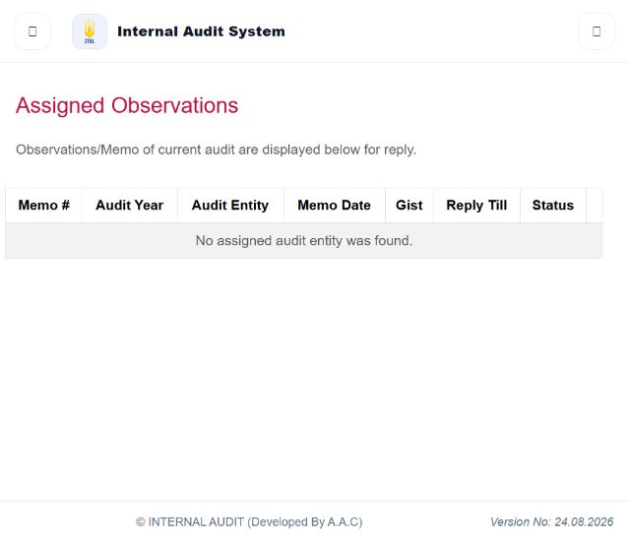
Figure 6.1: Observation Assigned
Purpose: Display observations or memos assigned to the signed-in auditee for reply.
Access: Users whose IAS page/menu permissions expose this screen. Review/approval/administration actions additionally depend on the actions enabled for the signed-in profile.
Main fields and controls: Memo number, audit year, audit entity, memo date, gist, Reply Till and Status.

Procedure
- Open Auditee Portal > Observation Assigned.
- Locate the assigned memo and check the Reply Till date and current status.
- Open the available row/action and enter the response and any permitted evidence.
- Submit the response and confirm the updated status.
Expected result: The auditee response is attached to the assigned item and its workflow status is updated.

7. Post Compliance

7.1 Post Compliance
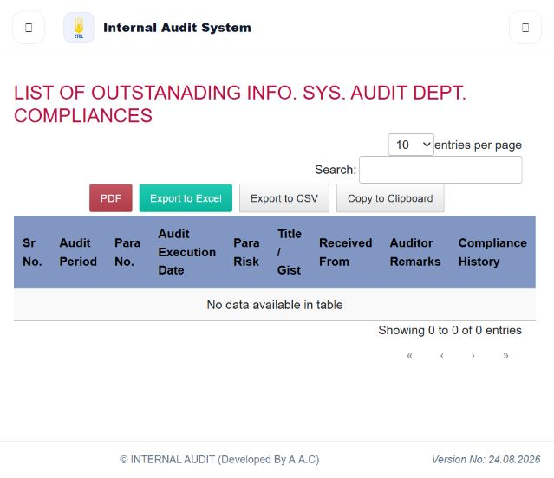
Figure 7.1: Post Compliance
Purpose: Review outstanding compliance items and their compliance history.
Access: Users whose IAS page/menu permissions expose this screen. Review/approval/administration actions additionally depend on the actions enabled for the signed-in profile.
Main fields and controls: Page size, Search, PDF, Export to Excel, Export to CSV, Copy to Clipboard and compliance-history table.

Procedure
- Open Post Compliance > Post Compliance.
- Use Search to narrow the displayed records.
- Review the audit period, para, dates, title/gist, source and compliance history.
- Use PDF, Excel, CSV or Copy only when an output is required.
Expected result: The list is filtered on screen or exported in the selected format.

8. I&ID

8.1 IID Case Dashboard
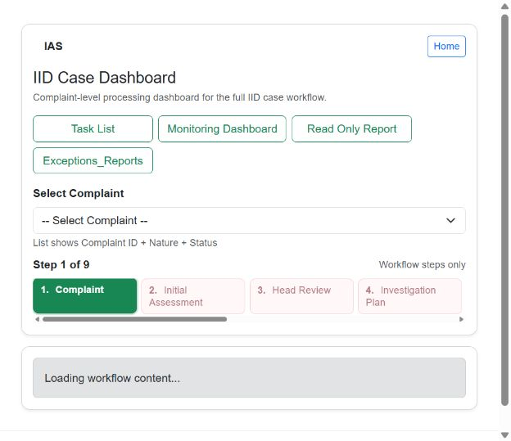
Figure 8.1: IID Case Dashboard
Purpose: Navigate the complaint/inquiry case workflow from complaint through final approval.
Access: Users whose IAS page/menu permissions expose this screen. Review/approval/administration actions additionally depend on the actions enabled for the signed-in profile.
Main fields and controls: Task List, Monitoring Dashboard, Read Only Report, Exceptions Reports, complaint selector and numbered workflow stages.

Procedure
- Open I&ID > IID Dashboard.
- Select a complaint from the list.
- Choose the active workflow stage, such as Complaint, Initial Assessment or Head Review.
- Complete the fields and actions displayed inside that stage.
- Return to Task List or Monitoring Dashboard to verify progress; use Read Only Report when a non-editable report is needed.
Expected result: The case remains at, or advances from, the selected workflow stage according to the action completed.

9. Reports

9.1 Monitoring of Settlement of Para
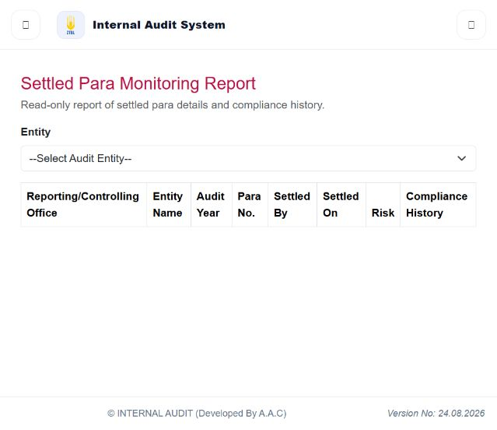
Figure 9.1: Monitoring of Settlement of Para
Purpose: Read the settled-para details and compliance history for a selected entity.
Access: Users whose IAS page/menu permissions expose this screen. Review/approval/administration actions additionally depend on the actions enabled for the signed-in profile.
Main fields and controls: Entity selector and report columns for office, entity, audit/para year, para number, settlement and compliance history.

Procedure
- Open Reports > Monitoring of Settlement of Para.
- Select an Entity.
- Review the returned rows and settlement/compliance columns.
- Use any export or print action only if it is displayed for the resulting report.
Expected result: IAS displays the settled-para monitoring data for the selected entity.

10. FAD

10.1 Field Auditor Dashboard
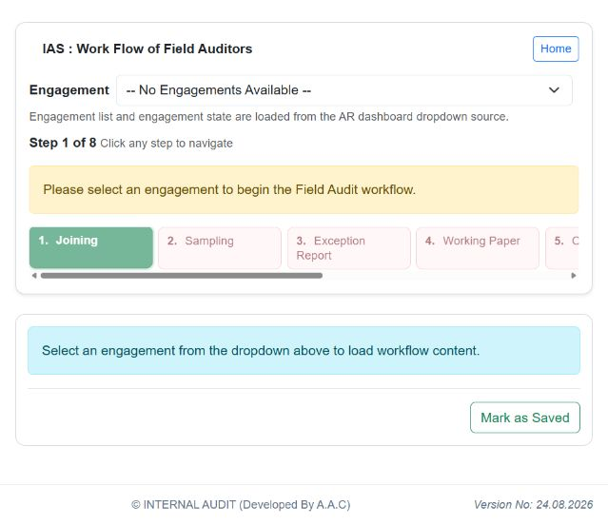
Figure 10.1: Field Auditor Dashboard
Purpose: Run the field-audit engagement workflow through the stages exposed for the selected engagement.
Access: Users whose IAS page/menu permissions expose this screen. Review/approval/administration actions additionally depend on the actions enabled for the signed-in profile.
Main fields and controls: Engagement selector, Joining, Sampling, Exception Report, Working Paper and later workflow stages; Mark as Saved.

Procedure
- Open FAD > Field Auditor Dashboard.
- Select an engagement.
- Choose the current enabled workflow step.
- Complete the controls loaded in the workspace.
- Use Mark as Saved when the stage content is complete enough to save, then continue to the next enabled stage.
Expected result: The selected engagement is saved at the current field-audit stage and later stages become available according to workflow state.

11. CAU

11.1 CAU Workflow
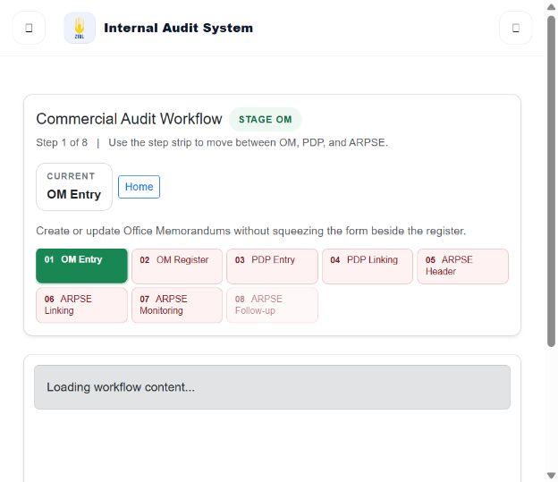
Figure 11.1: CAU Workflow
Purpose: Manage the commercial-audit sequence from entity selection through ARPSE follow-up.
Access: Users whose IAS page/menu permissions expose this screen. Review/approval/administration actions additionally depend on the actions enabled for the signed-in profile.
Main fields and controls: CM Entity, CM Register, PO Entry, PDF Linking, ARPSE Header, ARPSE Linking, ARPSE Monitoring and ARPSE Follow-up.

Procedure
- Open CAU > CAU Workflow.
- Select the current commercial-audit entity.
- Open the enabled workflow step.
- Complete the controls shown in the workspace and save or submit using the action displayed there.
- Continue to the next enabled step and use Monitoring or Follow-up for later-stage tracking.
Expected result: The commercial-audit item is saved at the selected stage and the workflow display refreshes.

12. Sampling

12.1 Monitoring of Samples
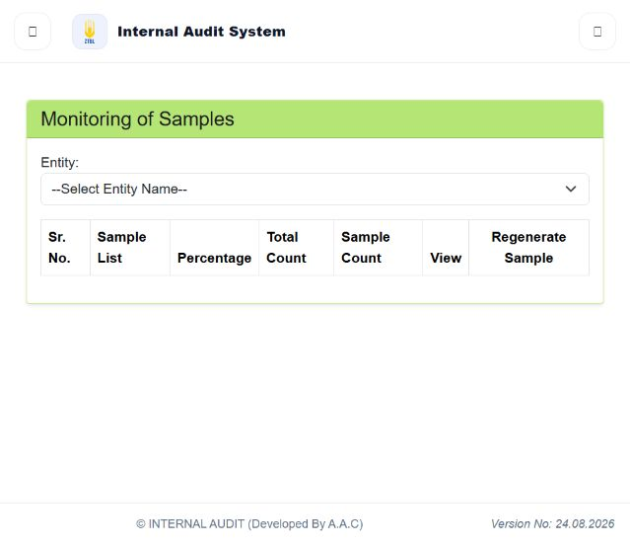
Figure 12.1: Monitoring of Samples
Purpose: Monitor samples by entity and use the available view or regeneration action.
Access: Users whose IAS page/menu permissions expose this screen. Review/approval/administration actions additionally depend on the actions enabled for the signed-in profile.
Main fields and controls: Entity, Sample List, Percentage, Total Count, Sample Count, View and Regenerate Sample.

Procedure
- Open Sampling > Monitoring of Samples.
- Select an Entity.
- Review sample percentage and counts.
- Choose View to inspect a sample or Regenerate Sample only when the displayed workflow permits it.
Expected result: IAS displays the selected sample details or refreshes the generated sample set.

13. Setup

13.1 Checklist Dashboard
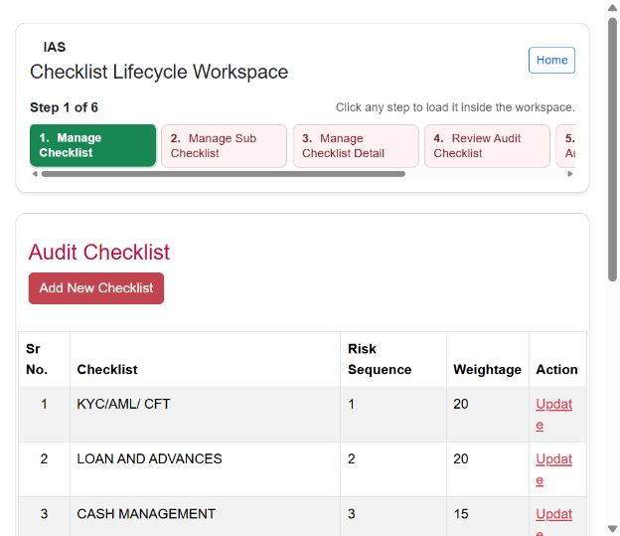
Figure 13.1: Checklist Dashboard
Purpose: Manage the checklist lifecycle through create, submit, detail, review and authorization stages.
Access: Users whose IAS page/menu permissions expose this screen. Review/approval/administration actions additionally depend on the actions enabled for the signed-in profile.
Main fields and controls: Six-step lifecycle, Add New Checklist, checklist table and row Update action.

Procedure
- Open Setup > Checklist Dashboard.
- Choose the relevant lifecycle stage.
- In Manage Checklist, select Add New Checklist or Update for an existing row.
- Complete the stage-specific fields and save/submit using the displayed action.
- Use the review or authorization stages only when they are enabled for your profile.
Expected result: The checklist is created or updated and its lifecycle state is reflected in the workspace.

14. Admin

14.1 Master Admin Control Panel and Manage Users
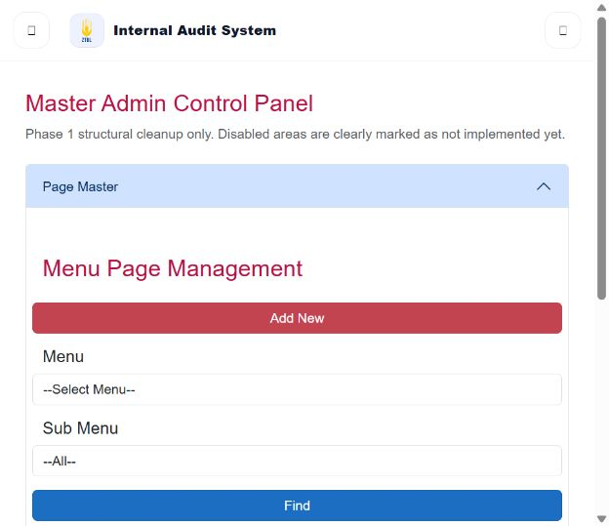
Figure 14.1: Master Admin Control Panel and Manage Users
Purpose: Maintain page/menu configuration and user records through permission-controlled administration screens.
Access: Users whose IAS page/menu permissions expose this screen. Review/approval/administration actions additionally depend on the actions enabled for the signed-in profile.
Main fields and controls: Master panel phase/accordion controls; Manage Users fields for relationship type, office, posting, P.P. number, login name, email, group/role and active status.

Procedure
- Open Admin > Master Admin Control Panel for menu/page configuration, or Admin > Manage Users for a user record.
- Use Find or the available filters before changing an existing record.
- Enter or update only the fields shown on the screen.
- Select the displayed Add, Update, Save or assignment action and confirm the refreshed record.
Expected result: IAS stores the configuration or user change; visibility and available actions remain subject to assigned rights.
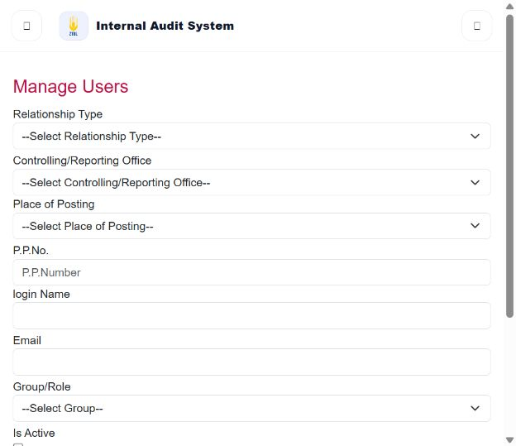
Figure 14.2: Manage Users
Restriction: administration screens change shared configuration and access. Confirm the target user, office, group/role and active status before saving.

15. Email

15.1 Email Management
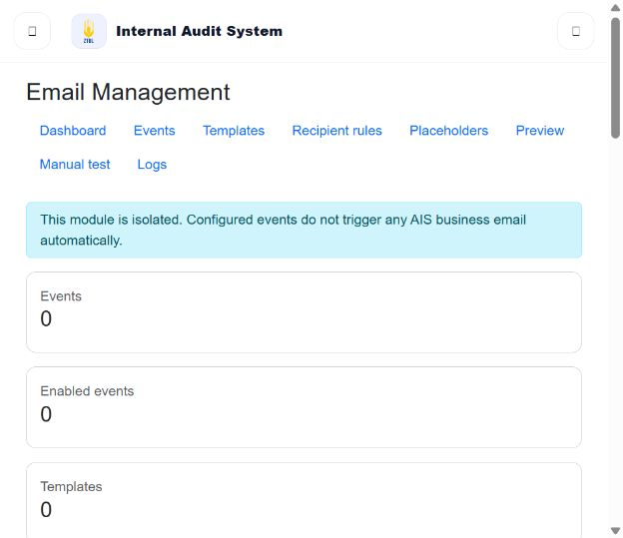
Figure 15.1: Email Management
Purpose: View and maintain the isolated email-management configuration area.
Access: Users whose IAS page/menu permissions expose this screen. Review/approval/administration actions additionally depend on the actions enabled for the signed-in profile.
Main fields and controls: Dashboard, Events, Templates, Recipient rules, Placeholders, Preview, Manual test and Logs.

Procedure
- Open Email > Dashboard.
- Choose Events, Templates, Recipient rules or Placeholders to maintain configuration.
- Use Preview before testing a message.
- Use Manual test only with approved test recipients.
- Review Logs for the recorded result.
Expected result: The selected email configuration or test result is saved and can be reviewed in Logs. The dashboard explicitly states that configured events do not automatically trigger IAS business email.

16. End-to-End User Workflows

Planning and engagement
Login → Planning: constitute teams / enter audit criteria → submit criteria → reviewer approval or return → generate/tentative plan → Engagement Plan List → approve or reject.

Observation and auditee response
Login → Execution: select entity and audit period → open observation → complete available observation action → Auditee Portal: open assigned observation → reply and attach permitted evidence → submit → verify status.

Draft and final report
Login → Execution: manage observations / draft report paras → quality review → finalize draft audit report → concluding/closing audit. FAD also exposes report overview, finalize report and PDF lists for its workflow.

Post compliance and settlement
Login → Post Compliance: find outstanding item → enter or review compliance → review stage → monitoring of settled paras. Reports provides settled-para and compliance progress views.

IID inquiry
Login → IID Dashboard → select complaint → Complaint → Initial Assessment → Head Review → Investigation Plan → Plan Approval → Analysis / Inquiry Report → Final Approval → read-only report or case study.

Commercial audit
Login → CAU Workflow → select commercial entity → CM Register → PO Entry → PDF Linking → ARPSE Header/Linking → Monitoring → Follow-up.

Checklist lifecycle
Login → Setup: Checklist Dashboard → manage checklist → submit → manage detail → review → authorize. Update/authorization screens are also available as separate menu items.

Email configuration/test
Login → Email Dashboard → configure events/templates/recipient rules/placeholders → Preview → Manual test → Logs. The verified dashboard states that events do not automatically trigger IAS business email.

17. Complete Verified Screen Catalog
This catalog lists every function exposed in the authenticated IAS menu during the review. It is the complete verified menu surface for the reviewed profile. Open paths are shown as menu labels, not technical URLs. Functions hidden from this profile cannot be confirmed as user-accessible.

Dashboard
Screen / function | How to open | Verified user use
BAC Analysis FAD | Dashboard > BAC Analysis FAD | Filter and review the named IAS report or monitoring view.
Line Management | Dashboard > Line Management | Find, add or update the named configuration records using the controls displayed on the screen.
Access and restrictions: permission-based. Use only the fields, row actions and workflow buttons displayed for the signed-in profile.

Planning
Screen / function | How to open | Verified user use
Constitute Teams | Planning > Constitute Teams | Prepare or maintain the named planning information and submit it through the displayed workflow.
Audit Criteria | Planning > Audit Criteria | Prepare or maintain the named planning information and submit it through the displayed workflow.
Reffered Back Audit Criteria | Planning > Reffered Back Audit Criteria | Prepare or maintain the named planning information and submit it through the displayed workflow.
Audit Criteria for Approval | Planning > Audit Criteria for Approval | Review the named item and use the decision actions displayed for the signed-in profile.
Approved Criteria / Generate Plan | Planning > Approved Criteria / Generate Plan | Prepare or maintain the named planning information and submit it through the displayed workflow.
Special Audit Plan | Planning > Special Audit Plan | Prepare or maintain the named planning information and submit it through the displayed workflow.
Special Audit Plan Approval | Planning > Special Audit Plan Approval | Review the named item and use the decision actions displayed for the signed-in profile.
Access and restrictions: permission-based. Use only the fields, row actions and workflow buttons displayed for the signed-in profile.

Engagement
Screen / function | How to open | Verified user use
Planning Dash Board | Engagement > Planning Dash Board | Prepare or maintain the named planning information and submit it through the displayed workflow.
Engagement Plan List | Engagement > Engagement Plan List | Prepare or maintain the named planning information and submit it through the displayed workflow.
Tentative Audit Plan | Engagement > Tentative Audit Plan | Prepare or maintain the named planning information and submit it through the displayed workflow.
Manage SBP Password | Engagement > Manage SBP Password | Find, add or update the named configuration records using the controls displayed on the screen.
Sbp Observation Register | Engagement > Sbp Observation Register | Open and work with the named IAS function using only the controls and actions displayed for the signed-in profile.
Reffered Back Engagement Plans | Engagement > Reffered Back Engagement Plans | Prepare or maintain the named planning information and submit it through the displayed workflow.
Access and restrictions: permission-based. Use only the fields, row actions and workflow buttons displayed for the signed-in profile.

Execution
Screen / function | How to open | Verified user use
Search / Find Check List | Execution > Search / Find Check List | Search for the named IAS records using the available filters.
Update Audit Paras | Execution > Update Audit Paras | Open and work with the named IAS function using only the controls and actions displayed for the signed-in profile.
Summary of Checklist | Execution > Summary of Checklist | Open and work with the named IAS function using only the controls and actions displayed for the signed-in profile.
Authorize Update Audit Paras | Execution > Authorize Update Audit Paras | Review the named item and use the decision actions displayed for the signed-in profile.
Create DSA | Execution > Create DSA | Open and work with the named IAS function using only the controls and actions displayed for the signed-in profile.
List Draft DSAs | Execution > List Draft DSAs | Open and work with the named IAS function using only the controls and actions displayed for the signed-in profile.
Authorize Delete Duplicate Para | Execution > Authorize Delete Duplicate Para | Review the named item and use the decision actions displayed for the signed-in profile.
Authorize Delete Duplicate Para | Execution > Authorize Delete Duplicate Para | Review the named item and use the decision actions displayed for the signed-in profile.
Quality Review of HO Paras | Execution > Quality Review of HO Paras | Review the named item and use the decision actions displayed for the signed-in profile.
Generate Observation PDF | Execution > Generate Observation PDF | Generate, open or download the named output when records are available.
Manage Observations | Execution > Manage Observations | Find, add or update the named configuration records using the controls displayed on the screen.
Manage Draft Report Paras | Execution > Manage Draft Report Paras | Filter and review the named IAS report or monitoring view.
Quality Review of Audit Paras | Execution > Quality Review of Audit Paras | Review the named item and use the decision actions displayed for the signed-in profile.
Finalize Draft Audit Report | Execution > Finalize Draft Audit Report | Filter and review the named IAS report or monitoring view.
Concluding Closing Audit | Execution > Concluding Closing Audit | Open and work with the named IAS function using only the controls and actions displayed for the signed-in profile.
Access and restrictions: permission-based. Use only the fields, row actions and workflow buttons displayed for the signed-in profile.

Auditee Portal
Screen / function | How to open | Verified user use
CCQs of Departments | Auditee Portal > CCQs of Departments | Open and work with the named IAS function using only the controls and actions displayed for the signed-in profile.
Observation Assigned | Auditee Portal > Observation Assigned | Open and work with the named IAS function using only the controls and actions displayed for the signed-in profile.
Access and restrictions: permission-based. Use only the fields, row actions and workflow buttons displayed for the signed-in profile.

Post Compliance
Screen / function | How to open | Verified user use
Post Compliance | Post Compliance > Post Compliance | Open the named work item, complete the displayed response fields and submit through the available workflow action.
Para Shifting | Post Compliance > Para Shifting | Find, add or update the named configuration records using the controls displayed on the screen.
Post Compliance For Review | Post Compliance > Post Compliance For Review | Review the named item and use the decision actions displayed for the signed-in profile.
Monitoring of Settled Paras | Post Compliance > Monitoring of Settled Paras | Filter and review the named IAS report or monitoring view.
CAU Paras Submission to Branch | Post Compliance > CAU Paras Submission to Branch | Open and work with the named IAS function using only the controls and actions displayed for the signed-in profile.
CAU Paras Branch Reply | Post Compliance > CAU Paras Branch Reply | Open the named work item, complete the displayed response fields and submit through the available workflow action.
Review Settle New/AIS Paras | Post Compliance > Review Settle New/AIS Paras | Review the named item and use the decision actions displayed for the signed-in profile.
Review of CAU Paras Branch Reply | Post Compliance > Review of CAU Paras Branch Reply | Review the named item and use the decision actions displayed for the signed-in profile.
Access and restrictions: permission-based. Use only the fields, row actions and workflow buttons displayed for the signed-in profile.

I&ID
Screen / function | How to open | Verified user use
IID Dashboard | I&ID > IID Dashboard | Open the module workspace and review the current work/status summary.
Monitoring Dashboard | I&ID > Monitoring Dashboard | Open the module workspace and review the current work/status summary.
Submit Complaint | I&ID > Submit Complaint | Open the named work item, complete the displayed response fields and submit through the available workflow action.
Initial Assessment | I&ID > Initial Assessment | Open and work with the named IAS function using only the controls and actions displayed for the signed-in profile.
Head Review | I&ID > Head Review | Review the named item and use the decision actions displayed for the signed-in profile.
Inquiry Report PDF | I&ID > Inquiry Report PDF | Filter and review the named IAS report or monitoring view.
Investigation Plan | I&ID > Investigation Plan | Prepare or maintain the named planning information and submit it through the displayed workflow.
Plan Approval | I&ID > Plan Approval | Review the named item and use the decision actions displayed for the signed-in profile.
Inquiry Report | I&ID > Inquiry Report | Filter and review the named IAS report or monitoring view.
account document | I&ID > account document | Open and work with the named IAS function using only the controls and actions displayed for the signed-in profile.
Analysis | I&ID > Analysis | Filter and review the named IAS report or monitoring view.
account transaction | I&ID > account transaction | Open and work with the named IAS function using only the controls and actions displayed for the signed-in profile.
Exceptions Reports | I&ID > Exceptions Reports | Filter and review the named IAS report or monitoring view.
Final Approval | I&ID > Final Approval | Review the named item and use the decision actions displayed for the signed-in profile.
Account exception | I&ID > Account exception | Open and work with the named IAS function using only the controls and actions displayed for the signed-in profile.
Case Study | I&ID > Case Study | Open and work with the named IAS function using only the controls and actions displayed for the signed-in profile.
loan documents | I&ID > loan documents | Open and work with the named IAS function using only the controls and actions displayed for the signed-in profile.
loan transactions | I&ID > loan transactions | Open and work with the named IAS function using only the controls and actions displayed for the signed-in profile.
Reports | I&ID > Reports | Filter and review the named IAS report or monitoring view.
TaskListIID | I&ID > TaskListIID | Open and work with the named IAS function using only the controls and actions displayed for the signed-in profile.
Access and restrictions: permission-based. Use only the fields, row actions and workflow buttons displayed for the signed-in profile.

Reports
Screen / function | How to open | Verified user use
Monitoring of Settlement of Para | Reports > Monitoring of Settlement of Para | Filter and review the named IAS report or monitoring view.
Search Text in Audit Paras | Reports > Search Text in Audit Paras | Search for the named IAS records using the available filters.
Compliance Progress Report | Reports > Compliance Progress Report | Filter and review the named IAS report or monitoring view.
Audit Cluster Wise Para Position | Reports > Audit Cluster Wise Para Position | Open and work with the named IAS function using only the controls and actions displayed for the signed-in profile.
Paras Settlement Report | Reports > Paras Settlement Report | Filter and review the named IAS report or monitoring view.
Gist Wise Report | Reports > Gist Wise Report | Filter and review the named IAS report or monitoring view.
FAD Monthly Review | Reports > FAD Monthly Review | Review the named item and use the decision actions displayed for the signed-in profile.
Engagment Plan Delay Analysis Report | Reports > Engagment Plan Delay Analysis Report | Filter and review the named IAS report or monitoring view.
Joining / Completion Report | Reports > Joining / Completion Report | Filter and review the named IAS report or monitoring view.
Access and restrictions: permission-based. Use only the fields, row actions and workflow buttons displayed for the signed-in profile.

FAD
Screen / function | How to open | Verified user use
Consolidated Outstanding Paras pdf | FAD > Consolidated Outstanding Paras pdf | Generate, open or download the named output when records are available.
Quality_Assurance_checking | FAD > Quality_Assurance_checking | Review the named item and use the decision actions displayed for the signed-in profile.
Draft_report_Checking | FAD > Draft_report_Checking | Filter and review the named IAS report or monitoring view.
Management Auditor Dashboard | FAD > Management Auditor Dashboard | Open the module workspace and review the current work/status summary.
Back Office Dashboard | FAD > Back Office Dashboard | Open the module workspace and review the current work/status summary.
Field Auditor Dashboard | FAD > Field Auditor Dashboard | Open the module workspace and review the current work/status summary.
Finalize Report | FAD > Finalize Report | Filter and review the named IAS report or monitoring view.
FAD Reports | FAD > FAD Reports | Filter and review the named IAS report or monitoring view.
Report Overview | FAD > Report Overview | Filter and review the named IAS report or monitoring view.
Para Status Change | FAD > Para Status Change | Open and work with the named IAS function using only the controls and actions displayed for the signed-in profile.
List of Pdf | FAD > List of Pdf | Generate, open or download the named output when records are available.
Management Audit Report | FAD > Management Audit Report | Filter and review the named IAS report or monitoring view.
Annexure Configuration | FAD > Annexure Configuration | Find, add or update the named configuration records using the controls displayed on the screen.
Management Finalize Report | FAD > Management Finalize Report | Filter and review the named IAS report or monitoring view.
Access and restrictions: permission-based. Use only the fields, row actions and workflow buttons displayed for the signed-in profile.

CAU
Screen / function | How to open | Verified user use
CAU WorkFlow | CAU > CAU WorkFlow | Open and work with the named IAS function using only the controls and actions displayed for the signed-in profile.
ARPSE Year Wise Report | CAU > ARPSE Year Wise Report | Filter and review the named IAS report or monitoring view.
Detailed Para View | CAU > Detailed Para View | Open and work with the named IAS function using only the controls and actions displayed for the signed-in profile.
Arpse Follow Up | CAU > Arpse Follow Up | Open the named work item, complete the displayed response fields and submit through the available workflow action.
Access and restrictions: permission-based. Use only the fields, row actions and workflow buttons displayed for the signed-in profile.

Sampling
Screen / function | How to open | Verified user use
Manage Exception Report Format | Sampling > Manage Exception Report Format | Filter and review the named IAS report or monitoring view.
Add New Report | Sampling > Add New Report | Filter and review the named IAS report or monitoring view.
Monitoring of Samples | Sampling > Monitoring of Samples | Filter and review the named IAS report or monitoring view.
Monitoring of Exception Reports | Sampling > Monitoring of Exception Reports | Filter and review the named IAS report or monitoring view.
Access and restrictions: permission-based. Use only the fields, row actions and workflow buttons displayed for the signed-in profile.

Setup
Screen / function | How to open | Verified user use
Checklist Dashboard | Setup > Checklist Dashboard | Open the module workspace and review the current work/status summary.
Update Audit Entities | Setup > Update Audit Entities | Open and work with the named IAS function using only the controls and actions displayed for the signed-in profile.
Authorize Update Audit Entities | Setup > Authorize Update Audit Entities | Review the named item and use the decision actions displayed for the signed-in profile.
Access and restrictions: permission-based. Use only the fields, row actions and workflow buttons displayed for the signed-in profile.

Admin
Screen / function | How to open | Verified user use
User Dashboard | Admin > User Dashboard | Open the module workspace and review the current work/status summary.
Entity Dashboard | Admin > Entity Dashboard | Open the module workspace and review the current work/status summary.
Master Admin Control Panel | Admin > Master Admin Control Panel | Open and work with the named IAS function using only the controls and actions displayed for the signed-in profile.
Groups | Admin > Groups | Open and work with the named IAS function using only the controls and actions displayed for the signed-in profile.
Manage Public Holidays | Admin > Manage Public Holidays | Find, add or update the named configuration records using the controls displayed on the screen.
AIS Post Compliance | Admin > AIS Post Compliance | Open the named work item, complete the displayed response fields and submit through the available workflow action.
dashboard layout | Admin > dashboard layout | Open the module workspace and review the current work/status summary.
Group Menu/Page Assignment | Admin > Group Menu/Page Assignment | Find, add or update the named configuration records using the controls displayed on the screen.
Menu Assignment | Admin > Menu Assignment | Find, add or update the named configuration records using the controls displayed on the screen.
Sub Menu Management | Admin > Sub Menu Management | Find, add or update the named configuration records using the controls displayed on the screen.
Master API | Admin > Master API | Open and work with the named IAS function using only the controls and actions displayed for the signed-in profile.
catalog_uploads | Admin > catalog_uploads | Open and work with the named IAS function using only the controls and actions displayed for the signed-in profile.
Pages Management | Admin > Pages Management | Find, add or update the named configuration records using the controls displayed on the screen.
Manage Users | Admin > Manage Users | Find, add or update the named configuration records using the controls displayed on the screen.
Manage Audit and Compliance Offices | Admin > Manage Audit and Compliance Offices | Find, add or update the named configuration records using the controls displayed on the screen.
Manage User Rights | Admin > Manage User Rights | Find, add or update the named configuration records using the controls displayed on the screen.
System Logs | Admin > System Logs | Open and work with the named IAS function using only the controls and actions displayed for the signed-in profile.
Entity Addition | Admin > Entity Addition | Find, add or update the named configuration records using the controls displayed on the screen.
Entity Shifting | Admin > Entity Shifting | Find, add or update the named configuration records using the controls displayed on the screen.
Engagement Reversal | Admin > Engagement Reversal | Open and work with the named IAS function using only the controls and actions displayed for the signed-in profile.
Review Audit Checklist | Admin > Review Audit Checklist | Review the named item and use the decision actions displayed for the signed-in profile.
Authorize Audit Checklist | Admin > Authorize Audit Checklist | Review the named item and use the decision actions displayed for the signed-in profile.
Setup Auditee Entities | Admin > Setup Auditee Entities | Find, add or update the named configuration records using the controls displayed on the screen.
Entity Shifting History | Admin > Entity Shifting History | Find, add or update the named configuration records using the controls displayed on the screen.
Manage Version History | Admin > Manage Version History | Find, add or update the named configuration records using the controls displayed on the screen.
Access and restrictions: permission-based. Use only the fields, row actions and workflow buttons displayed for the signed-in profile.

Email
Screen / function | How to open | Verified user use
Dashboard | Email > Dashboard | Open the module workspace and review the current work/status summary.
Events | Email > Events | Open and work with the named IAS function using only the controls and actions displayed for the signed-in profile.
LogDetail | Email > LogDetail | Open and work with the named IAS function using only the controls and actions displayed for the signed-in profile.
Logs | Email > Logs | Open and work with the named IAS function using only the controls and actions displayed for the signed-in profile.
Placeholders | Email > Placeholders | Open and work with the named IAS function using only the controls and actions displayed for the signed-in profile.
Preview | Email > Preview | Review the named item and use the decision actions displayed for the signed-in profile.
Rules | Email > Rules | Open and work with the named IAS function using only the controls and actions displayed for the signed-in profile.
Templates | Email > Templates | Open and work with the named IAS function using only the controls and actions displayed for the signed-in profile.
Test | Email > Test | Open and work with the named IAS function using only the controls and actions displayed for the signed-in profile.
Access and restrictions: permission-based. Use only the fields, row actions and workflow buttons displayed for the signed-in profile.

18. Validation, Uploads, Search and Outputs

Validation
Required selections and field rules are enforced by the individual screen. Correct highlighted or on-screen validation messages before trying again. Do not infer acceptance from a button click; confirm the refreshed row, status or confirmation message.

File/evidence handling
IAS contains file/evidence upload and retrieval functions in observation/report workflows and catalog/PDF areas. Associate a file only with the intended record, avoid unnecessary personal data, and confirm the file appears in the record-specific list. Exact extensions and size limits vary by screen and should be followed from its displayed validation message.

Search/filtering
Select required parent values, enter search text where provided, then review the returned table. Clear or change the filter to broaden results.

Reports/downloads
Select the required entity, period or status first. Generate or export only with the button shown by the screen. Verify the downloaded title and selected scope before distributing it.

Errors and support
If a screen remains empty after required filters, an action is disabled, or an error persists, record the screen name and time without including confidential record content, then contact the IAS support/administration team.

19. Figure Index and Verification Note
Figure 2.1: IAS Home and dashboard workspace — authenticated local IAS view (Figure_02_01_IAS_Home.png)
Figure 3.1: Audit Criteria — authenticated local IAS view (Figure_03_01_Planning_Audit_Criteria.png)
Figure 4.1: Engagement Plan List — authenticated local IAS view (Figure_04_01_Engagement_Plan_List.png)
Figure 5.1: Manage Audit Observations — authenticated local IAS view (Figure_05_01_Execution_Manage_Observations.png)
Figure 6.1: Auditee Assigned Observations — authenticated local IAS view (Figure_06_01_Auditee_Observation_Assigned.png)
Figure 7.1: Post Compliance list and export controls — authenticated local IAS view (Figure_07_01_Post_Compliance.png)
Figure 8.1: IID Case Dashboard — authenticated local IAS view (Figure_08_01_IID_Dashboard.png)
Figure 9.1: Settled Para Monitoring Report — authenticated local IAS view (Figure_09_01_Reports_Para_Settlement.png)
Figure 10.1: Field Audit workflow dashboard — authenticated local IAS view (Figure_10_01_FAD_Field_Auditor_Dashboard.png)
Figure 11.1: Commercial Audit workflow — authenticated local IAS view (Figure_11_01_CAU_Workflow.png)
Figure 12.1: Monitoring of Samples — authenticated local IAS view (Figure_12_01_Sampling_Monitoring.png)
Figure 13.1: Checklist Lifecycle Workspace — authenticated local IAS view (Figure_13_01_Setup_Checklist_Dashboard.png)
Figure 14.1: Master Admin Control Panel — authenticated local IAS view (Figure_14_01_Admin_Master_Control.png)
Figure 14.2: Manage Users — authenticated local IAS view (Figure_14_02_Admin_Manage_Users.png)
Figure 15.1: Email Management dashboard — authenticated local IAS view (Figure_15_01_Email_Dashboard.png)
Verification basis: menu/routes and user-facing behaviour were checked against the IAS source tree and the authenticated local application on 28 August 2026. The manual intentionally does not contain passwords, PP numbers, connection strings, database objects or other internal implementation details. Screenshots show the post-login application viewport and contain no populated confidential business records.

20. Role-Based User Guide
Each role below was authenticated separately with the supplied test account. The module list records what was actually visible in the left navigation on 28 August 2026. A module not listed for the role was not available from that role's verified landing page. Detailed procedures and workflow screenshots are provided in Sections 3-18.

20.1 Super User
Role purpose: Administer the IAS permission estate and access all configured operational modules.
Verified landing page: IAS Home. Visible functional modules: Dashboard, Planning, Engagement, Execution, Auditee Portal, Post Compliance, I&ID, Reports, FAD, CAU, Sampling, Setup, Admin, Email.
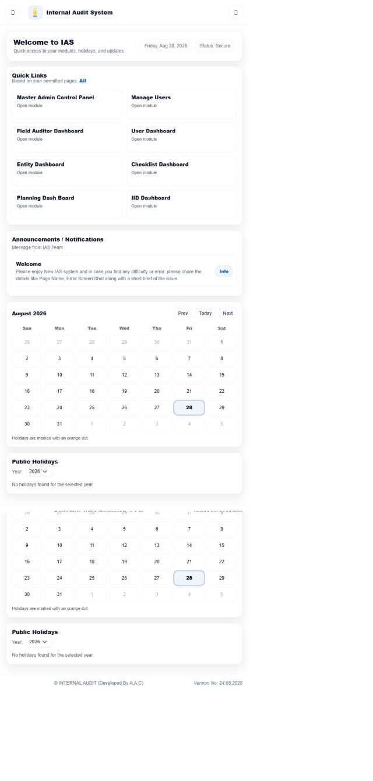
Figure 20.1: Super User verified IAS dashboard

Role operating procedure
- Sign in and, when the Select Working Context page appears, select the required role/posting context.
- Confirm that the IAS Home page opens and review the left navigation against the verified module list above.
- Open the required permitted module, select the relevant entity, period, engagement or work item, and review its current status.
- Use only the action displayed for the role. Team Members prepare and submit assigned work; Team Leads and Heads perform the review/decision actions exposed to them; auditees provide responses; administration roles maintain shared setup only where enabled.
- Confirm the resulting status, refreshed row, report or confirmation message before leaving the screen.
Restricted/hidden functions: all modules not listed above were absent from the verified landing menu. Button-level actions remain conditional on the selected record and workflow status.

20.2 Admin
Role purpose: Maintain users, configuration and assigned operational administration functions.
Verified landing page: IAS Home. Visible functional modules: Dashboard, Engagement, Execution, Post Compliance, Reports, FAD, CAU, Setup, Admin.
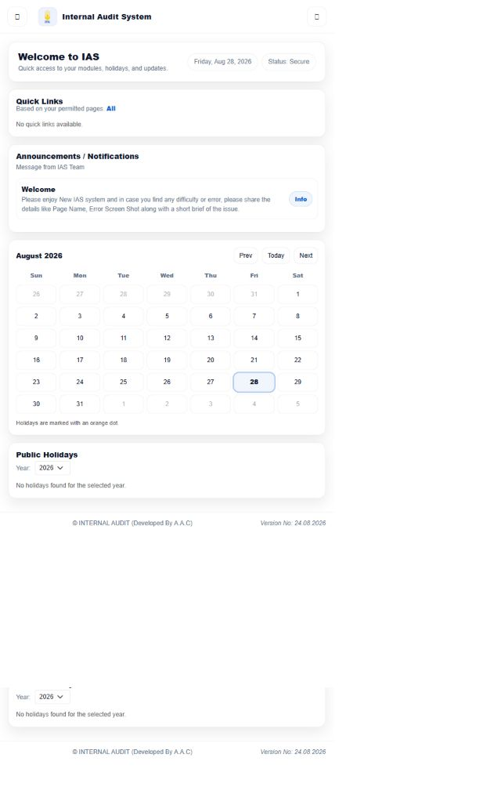
Figure 20.2: Admin verified IAS dashboard

Role operating procedure
- Sign in and, when the Select Working Context page appears, select the required role/posting context.
- Confirm that the IAS Home page opens and review the left navigation against the verified module list above.
- Open the required permitted module, select the relevant entity, period, engagement or work item, and review its current status.
- Use only the action displayed for the role. Team Members prepare and submit assigned work; Team Leads and Heads perform the review/decision actions exposed to them; auditees provide responses; administration roles maintain shared setup only where enabled.
- Confirm the resulting status, refreshed row, report or confirmation message before leaving the screen.
Restricted/hidden functions: all modules not listed above were absent from the verified landing menu. Button-level actions remain conditional on the selected record and workflow status.

20.3 Zonal Chief
Role purpose: Monitor zonal audit results, auditee work and post-compliance reporting.
Verified landing page: IAS Home. Visible functional modules: Dashboard, Auditee Portal, Post Compliance, Reports.

Figure 20.3: Zonal Chief verified IAS dashboard

Role operating procedure
- Sign in and, when the Select Working Context page appears, select the required role/posting context.
- Confirm that the IAS Home page opens and review the left navigation against the verified module list above.
- Open the required permitted module, select the relevant entity, period, engagement or work item, and review its current status.
- Use only the action displayed for the role. Team Members prepare and submit assigned work; Team Leads and Heads perform the review/decision actions exposed to them; auditees provide responses; administration roles maintain shared setup only where enabled.
- Confirm the resulting status, refreshed row, report or confirmation message before leaving the screen.
Restricted/hidden functions: all modules not listed above were absent from the verified landing menu. Button-level actions remain conditional on the selected record and workflow status.

20.4 Head FAD
Role purpose: Oversee field-audit planning, execution, quality, reporting and compliance.
Verified landing page: IAS Home. Visible functional modules: Dashboard, Planning, Engagement, Execution, Post Compliance, Reports, FAD, CAU, Sampling, Setup.

Figure 20.4: Head FAD verified IAS dashboard

Role operating procedure
- Sign in and, when the Select Working Context page appears, select the required role/posting context.
- Confirm that the IAS Home page opens and review the left navigation against the verified module list above.
- Open the required permitted module, select the relevant entity, period, engagement or work item, and review its current status.
- Use only the action displayed for the role. Team Members prepare and submit assigned work; Team Leads and Heads perform the review/decision actions exposed to them; auditees provide responses; administration roles maintain shared setup only where enabled.
- Confirm the resulting status, refreshed row, report or confirmation message before leaving the screen.
Restricted/hidden functions: all modules not listed above were absent from the verified landing menu. Button-level actions remain conditional on the selected record and workflow status.

20.5 Head CAD
Role purpose: Oversee central/credit audit risk, planning, execution and compliance workflows.
Verified landing page: IAS Home. Visible functional modules: Dashboard, Risk, Planning, Engagement, Execution, Post Compliance, Reports, Sampling, Setup.
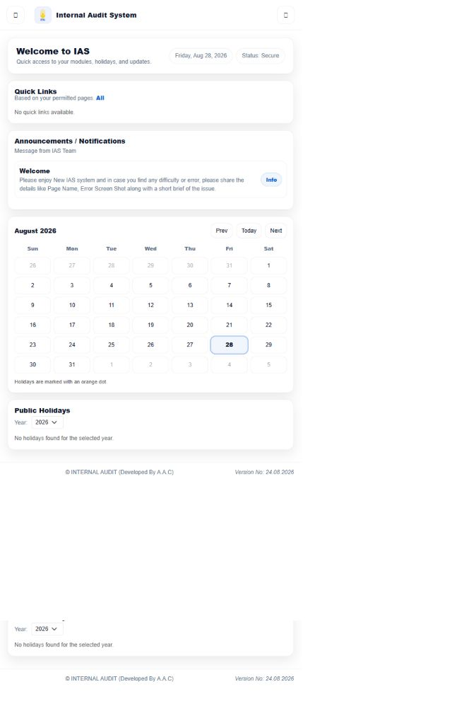
Figure 20.5: Head CAD verified IAS dashboard

Role operating procedure
- Sign in and, when the Select Working Context page appears, select the required role/posting context.
- Confirm that the IAS Home page opens and review the left navigation against the verified module list above.
- Open the required permitted module, select the relevant entity, period, engagement or work item, and review its current status.
- Use only the action displayed for the role. Team Members prepare and submit assigned work; Team Leads and Heads perform the review/decision actions exposed to them; auditees provide responses; administration roles maintain shared setup only where enabled.
- Confirm the resulting status, refreshed row, report or confirmation message before leaving the screen.
Restricted/hidden functions: all modules not listed above were absent from the verified landing menu. Button-level actions remain conditional on the selected record and workflow status.

20.6 Head ISAD
Role purpose: Oversee information-systems audit risk, planning, execution, reporting and administration.
Verified landing page: IAS Home. Visible functional modules: Dashboard, Risk, Planning, Engagement, Execution, Post Compliance, Reports, FAD, Sampling, Setup, Admin.
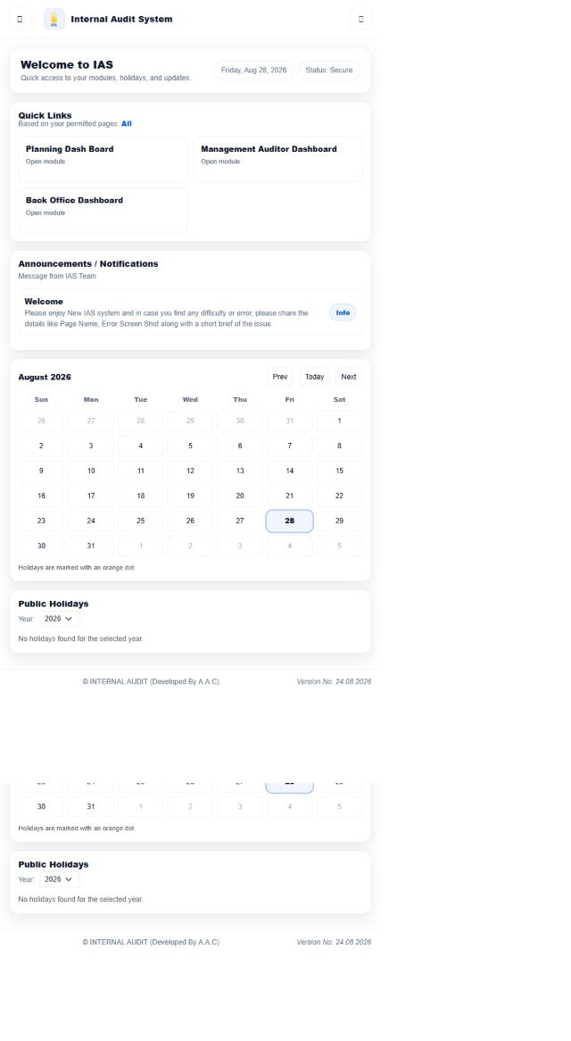
Figure 20.6: Head ISAD verified IAS dashboard

Role operating procedure
- Sign in and, when the Select Working Context page appears, select the required role/posting context.
- Confirm that the IAS Home page opens and review the left navigation against the verified module list above.
- Open the required permitted module, select the relevant entity, period, engagement or work item, and review its current status.
- Use only the action displayed for the role. Team Members prepare and submit assigned work; Team Leads and Heads perform the review/decision actions exposed to them; auditees provide responses; administration roles maintain shared setup only where enabled.
- Confirm the resulting status, refreshed row, report or confirmation message before leaving the screen.
Restricted/hidden functions: all modules not listed above were absent from the verified landing menu. Button-level actions remain conditional on the selected record and workflow status.

20.7 HO Auditor (Team Lead)
Role purpose: Lead Head Office audit execution, review team work and progress assigned items.
Verified landing page: IAS Home. Visible functional modules: Risk, Execution, Post Compliance, FAD.
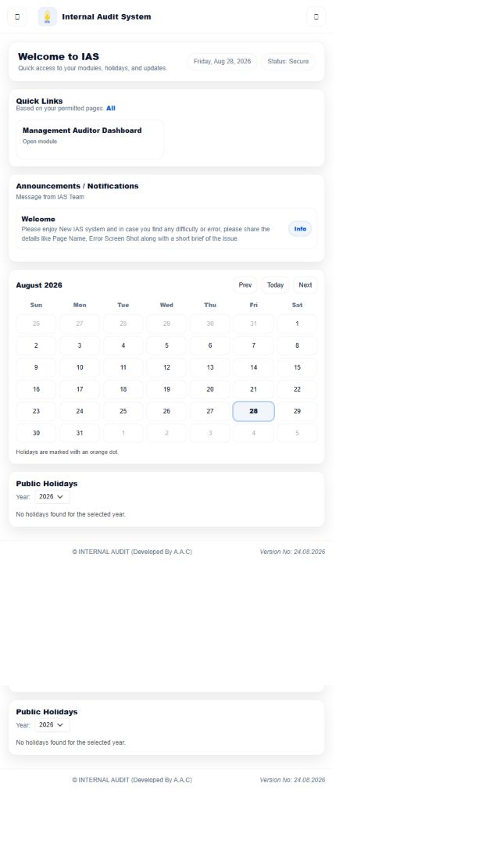
Figure 20.7: HO Auditor (Team Lead) verified IAS dashboard

Role operating procedure
- Sign in and, when the Select Working Context page appears, select the required role/posting context.
- Confirm that the IAS Home page opens and review the left navigation against the verified module list above.
- Open the required permitted module, select the relevant entity, period, engagement or work item, and review its current status.
- Use only the action displayed for the role. Team Members prepare and submit assigned work; Team Leads and Heads perform the review/decision actions exposed to them; auditees provide responses; administration roles maintain shared setup only where enabled.
- Confirm the resulting status, refreshed row, report or confirmation message before leaving the screen.
Restricted/hidden functions: all modules not listed above were absent from the verified landing menu. Button-level actions remain conditional on the selected record and workflow status.

20.8 HO Planning & Coordination
Role purpose: Coordinate Head Office planning, engagements, reporting and monitoring.
Verified landing page: IAS Home. Visible functional modules: Dashboard, Planning, Engagement, Execution, Post Compliance, Reports, FAD, Sampling, Admin.
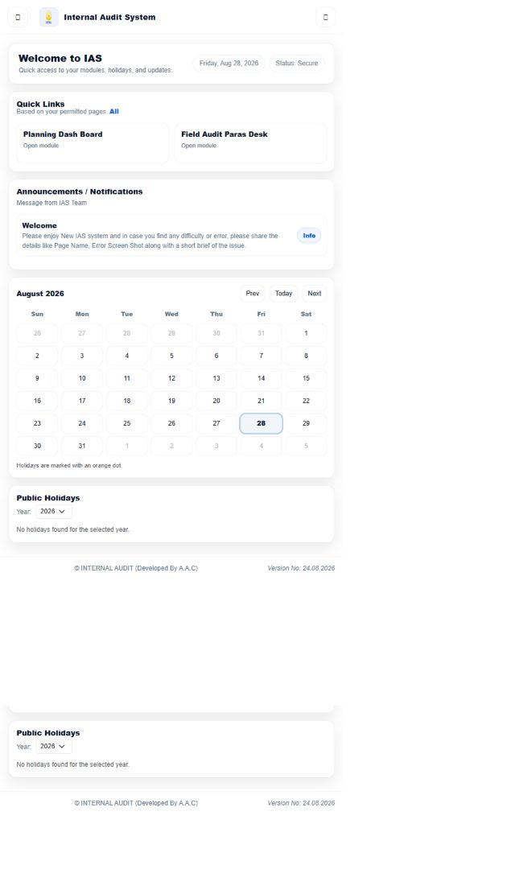
Figure 20.8: HO Planning & Coordination verified IAS dashboard

Role operating procedure
- Sign in and, when the Select Working Context page appears, select the required role/posting context.
- Confirm that the IAS Home page opens and review the left navigation against the verified module list above.
- Open the required permitted module, select the relevant entity, period, engagement or work item, and review its current status.
- Use only the action displayed for the role. Team Members prepare and submit assigned work; Team Leads and Heads perform the review/decision actions exposed to them; auditees provide responses; administration roles maintain shared setup only where enabled.
- Confirm the resulting status, refreshed row, report or confirmation message before leaving the screen.
Restricted/hidden functions: all modules not listed above were absent from the verified landing menu. Button-level actions remain conditional on the selected record and workflow status.

20.9 Dept Auditee
Role purpose: Review departmental observations, provide responses and monitor compliance.
Verified landing page: IAS Home. Visible functional modules: Dashboard, Auditee Portal, Post Compliance, Reports.

Figure 20.9: Dept Auditee verified IAS dashboard

Role operating procedure
- Sign in and, when the Select Working Context page appears, select the required role/posting context.
- Confirm that the IAS Home page opens and review the left navigation against the verified module list above.
- Open the required permitted module, select the relevant entity, period, engagement or work item, and review its current status.
- Use only the action displayed for the role. Team Members prepare and submit assigned work; Team Leads and Heads perform the review/decision actions exposed to them; auditees provide responses; administration roles maintain shared setup only where enabled.
- Confirm the resulting status, refreshed row, report or confirmation message before leaving the screen.
Restricted/hidden functions: all modules not listed above were absent from the verified landing menu. Button-level actions remain conditional on the selected record and workflow status.

20.10 Auditee Branch
Role purpose: Review branch observations, provide responses and monitor compliance.
Verified landing page: IAS Home. Visible functional modules: Dashboard, Auditee Portal, Post Compliance, Reports.

Figure 20.10: Auditee Branch verified IAS dashboard

Role operating procedure
- Sign in and, when the Select Working Context page appears, select the required role/posting context.
- Confirm that the IAS Home page opens and review the left navigation against the verified module list above.
- Open the required permitted module, select the relevant entity, period, engagement or work item, and review its current status.
- Use only the action displayed for the role. Team Members prepare and submit assigned work; Team Leads and Heads perform the review/decision actions exposed to them; auditees provide responses; administration roles maintain shared setup only where enabled.
- Confirm the resulting status, refreshed row, report or confirmation message before leaving the screen.
Restricted/hidden functions: all modules not listed above were absent from the verified landing menu. Button-level actions remain conditional on the selected record and workflow status.

20.11 Div Auditee
Role purpose: Review divisional observations, provide responses and monitor compliance.
Verified landing page: IAS Home. Visible functional modules: Dashboard, Auditee Portal, Post Compliance, Reports.

Figure 20.11: Div Auditee verified IAS dashboard

Role operating procedure
- Sign in and, when the Select Working Context page appears, select the required role/posting context.
- Confirm that the IAS Home page opens and review the left navigation against the verified module list above.
- Open the required permitted module, select the relevant entity, period, engagement or work item, and review its current status.
- Use only the action displayed for the role. Team Members prepare and submit assigned work; Team Leads and Heads perform the review/decision actions exposed to them; auditees provide responses; administration roles maintain shared setup only where enabled.
- Confirm the resulting status, refreshed row, report or confirmation message before leaving the screen.
Restricted/hidden functions: all modules not listed above were absent from the verified landing menu. Button-level actions remain conditional on the selected record and workflow status.

20.12 SVP Audit Zone
Role purpose: Supervise Audit Zone planning, execution, field-audit and compliance activity.
Verified landing page: IAS Home. Visible functional modules: Dashboard, Planning, Engagement, Execution, Post Compliance, Reports, FAD, Setup.
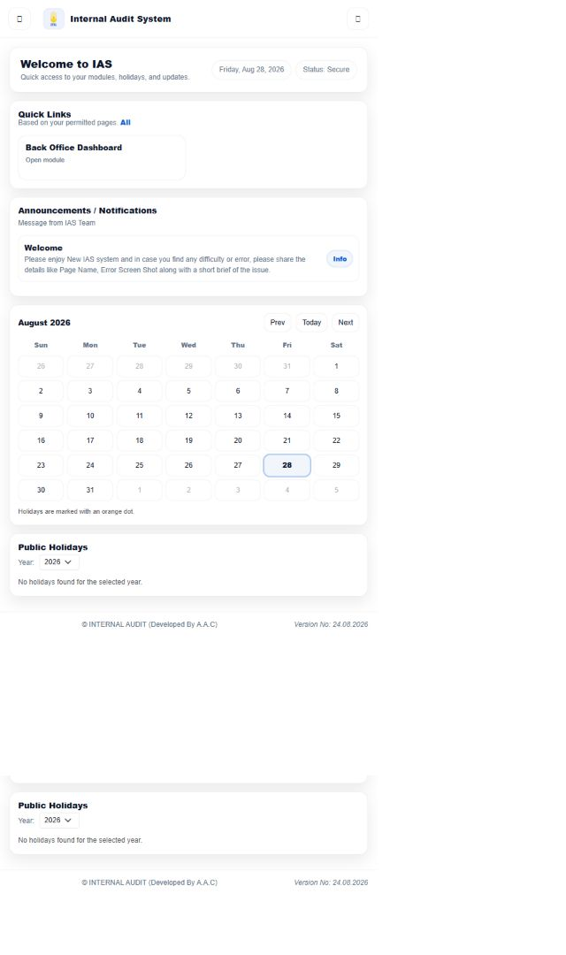
Figure 20.12: SVP Audit Zone verified IAS dashboard

Role operating procedure
- Sign in and, when the Select Working Context page appears, select the required role/posting context.
- Confirm that the IAS Home page opens and review the left navigation against the verified module list above.
- Open the required permitted module, select the relevant entity, period, engagement or work item, and review its current status.
- Use only the action displayed for the role. Team Members prepare and submit assigned work; Team Leads and Heads perform the review/decision actions exposed to them; auditees provide responses; administration roles maintain shared setup only where enabled.
- Confirm the resulting status, refreshed row, report or confirmation message before leaving the screen.
Restricted/hidden functions: all modules not listed above were absent from the verified landing menu. Button-level actions remain conditional on the selected record and workflow status.

20.13 AZ Implementation Unit
Role purpose: Implement Audit Zone plans and progress execution, reporting and compliance work.
Verified landing page: IAS Home. Visible functional modules: Dashboard, Planning, Engagement, Execution, Post Compliance, Reports, FAD.
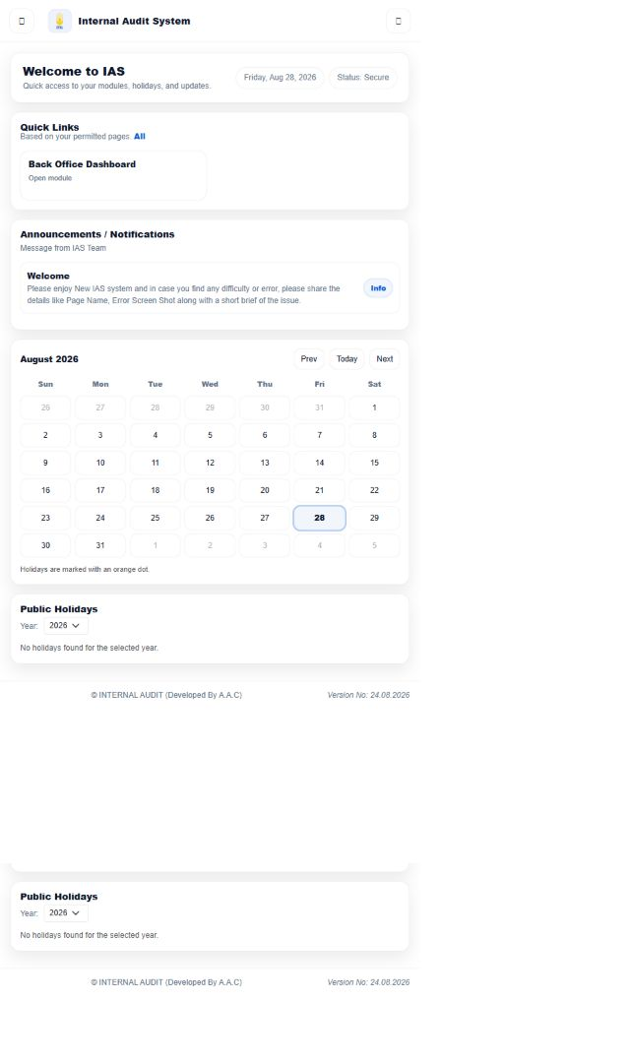
Figure 20.13: AZ Implementation Unit verified IAS dashboard

Role operating procedure
- Sign in and, when the Select Working Context page appears, select the required role/posting context.
- Confirm that the IAS Home page opens and review the left navigation against the verified module list above.
- Open the required permitted module, select the relevant entity, period, engagement or work item, and review its current status.
- Use only the action displayed for the role. Team Members prepare and submit assigned work; Team Leads and Heads perform the review/decision actions exposed to them; auditees provide responses; administration roles maintain shared setup only where enabled.
- Confirm the resulting status, refreshed row, report or confirmation message before leaving the screen.
Restricted/hidden functions: all modules not listed above were absent from the verified landing menu. Button-level actions remain conditional on the selected record and workflow status.

20.14 AZ Planning & Coordination
Role purpose: Coordinate Audit Zone execution, reporting and post-compliance work.
Verified landing page: IAS Home. Visible functional modules: Execution, Post Compliance, Reports.

Figure 20.14: AZ Planning & Coordination verified IAS dashboard

Role operating procedure
- Sign in and, when the Select Working Context page appears, select the required role/posting context.
- Confirm that the IAS Home page opens and review the left navigation against the verified module list above.
- Open the required permitted module, select the relevant entity, period, engagement or work item, and review its current status.
- Use only the action displayed for the role. Team Members prepare and submit assigned work; Team Leads and Heads perform the review/decision actions exposed to them; auditees provide responses; administration roles maintain shared setup only where enabled.
- Confirm the resulting status, refreshed row, report or confirmation message before leaving the screen.
Restricted/hidden functions: all modules not listed above were absent from the verified landing menu. Button-level actions remain conditional on the selected record and workflow status.

20.15 Branch Auditor (Team Lead)
Role purpose: Lead branch audit execution, sampling and field-audit workflow stages.
Verified landing page: IAS Home. Visible functional modules: Execution, Post Compliance, FAD, Sampling.
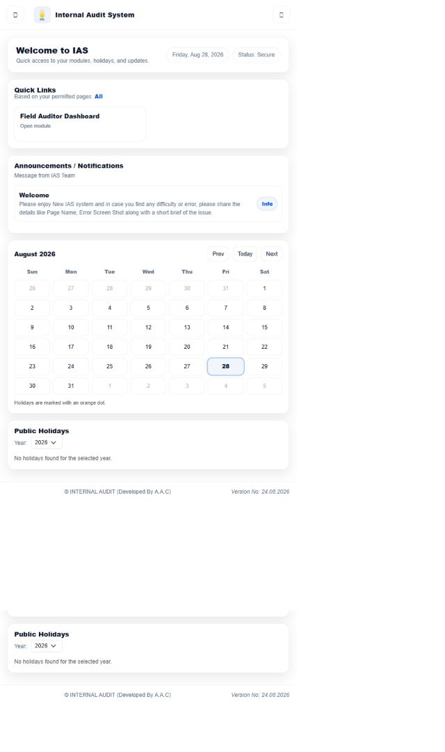
Figure 20.15: Branch Auditor (Team Lead) verified IAS dashboard

Role operating procedure
- Sign in and, when the Select Working Context page appears, select the required role/posting context.
- Confirm that the IAS Home page opens and review the left navigation against the verified module list above.
- Open the required permitted module, select the relevant entity, period, engagement or work item, and review its current status.
- Use only the action displayed for the role. Team Members prepare and submit assigned work; Team Leads and Heads perform the review/decision actions exposed to them; auditees provide responses; administration roles maintain shared setup only where enabled.
- Confirm the resulting status, refreshed row, report or confirmation message before leaving the screen.
Restricted/hidden functions: all modules not listed above were absent from the verified landing menu. Button-level actions remain conditional on the selected record and workflow status.

20.16 Audit QA Unit
Role purpose: Perform quality review and checklist-related assurance functions exposed by IAS.
Verified landing page: IAS Home. Visible functional modules: Execution, Setup.

Figure 20.16: Audit QA Unit verified IAS dashboard

Role operating procedure
- Sign in and, when the Select Working Context page appears, select the required role/posting context.
- Confirm that the IAS Home page opens and review the left navigation against the verified module list above.
- Open the required permitted module, select the relevant entity, period, engagement or work item, and review its current status.
- Use only the action displayed for the role. Team Members prepare and submit assigned work; Team Leads and Heads perform the review/decision actions exposed to them; auditees provide responses; administration roles maintain shared setup only where enabled.
- Confirm the resulting status, refreshed row, report or confirmation message before leaving the screen.
Restricted/hidden functions: all modules not listed above were absent from the verified landing menu. Button-level actions remain conditional on the selected record and workflow status.

20.17 Shariah Audit Unit
Role purpose: Perform Shariah audit risk, planning, engagement, execution and checklist work.
Verified landing page: IAS Home. Visible functional modules: Risk, Planning, Engagement, Execution, Setup.

Figure 20.17: Shariah Audit Unit verified IAS dashboard

Role operating procedure
- Sign in and, when the Select Working Context page appears, select the required role/posting context.
- Confirm that the IAS Home page opens and review the left navigation against the verified module list above.
- Open the required permitted module, select the relevant entity, period, engagement or work item, and review its current status.
- Use only the action displayed for the role. Team Members prepare and submit assigned work; Team Leads and Heads perform the review/decision actions exposed to them; auditees provide responses; administration roles maintain shared setup only where enabled.
- Confirm the resulting status, refreshed row, report or confirmation message before leaving the screen.
Restricted/hidden functions: all modules not listed above were absent from the verified landing menu. Button-level actions remain conditional on the selected record and workflow status.

20.18 HO Auditor (Team Member)
Role purpose: Prepare assigned Head Office audit work and submit it into team review flows.
Verified landing page: IAS Home. Visible functional modules: Execution, Auditee Portal, Post Compliance.

Figure 20.18: HO Auditor (Team Member) verified IAS dashboard

Role operating procedure
- Sign in and, when the Select Working Context page appears, select the required role/posting context.
- Confirm that the IAS Home page opens and review the left navigation against the verified module list above.
- Open the required permitted module, select the relevant entity, period, engagement or work item, and review its current status.
- Use only the action displayed for the role. Team Members prepare and submit assigned work; Team Leads and Heads perform the review/decision actions exposed to them; auditees provide responses; administration roles maintain shared setup only where enabled.
- Confirm the resulting status, refreshed row, report or confirmation message before leaving the screen.
Restricted/hidden functions: all modules not listed above were absent from the verified landing menu. Button-level actions remain conditional on the selected record and workflow status.

20.19 Branch Auditor (Team Member)
Role purpose: Prepare assigned branch audit and field-audit work for Team Lead review.
Verified landing page: IAS Home. Visible functional modules: Execution, Post Compliance, FAD.

Figure 20.19: Branch Auditor (Team Member) verified IAS dashboard

Role operating procedure
- Sign in and, when the Select Working Context page appears, select the required role/posting context.
- Confirm that the IAS Home page opens and review the left navigation against the verified module list above.
- Open the required permitted module, select the relevant entity, period, engagement or work item, and review its current status.
- Use only the action displayed for the role. Team Members prepare and submit assigned work; Team Leads and Heads perform the review/decision actions exposed to them; auditees provide responses; administration roles maintain shared setup only where enabled.
- Confirm the resulting status, refreshed row, report or confirmation message before leaving the screen.
Restricted/hidden functions: all modules not listed above were absent from the verified landing menu. Button-level actions remain conditional on the selected record and workflow status.

21. Role / Permission Matrix
Legend: check mark = module visible and available from the verified role menu; Not Available = module absent. Approval, edit and submission buttons are record/status dependent and are described in the role and workflow procedures rather than inferred from menu presence.

Table 21.1: Verified module access
Role | Dashboard | Risk | Planning | Engagement | Execution | Auditee Portal | Post Compliance
Super User | ✓ | Not Available | ✓ | ✓ | ✓ | ✓ | ✓
Admin | ✓ | Not Available | Not Available | ✓ | ✓ | Not Available | ✓
Zonal Chief | ✓ | Not Available | Not Available | Not Available | Not Available | ✓ | ✓
Head FAD | ✓ | Not Available | ✓ | ✓ | ✓ | Not Available | ✓
Head CAD | ✓ | ✓ | ✓ | ✓ | ✓ | Not Available | ✓
Head ISAD | ✓ | ✓ | ✓ | ✓ | ✓ | Not Available | ✓
HO Auditor (Team Lead) | Not Available | ✓ | Not Available | Not Available | ✓ | Not Available | ✓
HO Planning & Coordination | ✓ | Not Available | ✓ | ✓ | ✓ | Not Available | ✓
Dept Auditee | ✓ | Not Available | Not Available | Not Available | Not Available | ✓ | ✓
Auditee Branch | ✓ | Not Available | Not Available | Not Available | Not Available | ✓ | ✓
Div Auditee | ✓ | Not Available | Not Available | Not Available | Not Available | ✓ | ✓
SVP Audit Zone | ✓ | Not Available | ✓ | ✓ | ✓ | Not Available | ✓
AZ Implementation Unit | ✓ | Not Available | ✓ | ✓ | ✓ | Not Available | ✓
AZ Planning & Coordination | Not Available | Not Available | Not Available | Not Available | ✓ | Not Available | ✓
Branch Auditor (Team Lead) | Not Available | Not Available | Not Available | Not Available | ✓ | Not Available | ✓
Audit QA Unit | Not Available | Not Available | Not Available | Not Available | ✓ | Not Available | Not Available
Shariah Audit Unit | Not Available | ✓ | ✓ | ✓ | ✓ | Not Available | Not Available
HO Auditor (Team Member) | Not Available | Not Available | Not Available | Not Available | ✓ | ✓ | ✓
Branch Auditor (Team Member) | Not Available | Not Available | Not Available | Not Available | ✓ | Not Available | ✓

Table 21.2: Verified module access
Role | Reports | FAD | CAU | Sampling | Setup | Admin | Email
Super User | ✓ | ✓ | ✓ | ✓ | ✓ | ✓ | ✓
Admin | ✓ | ✓ | ✓ | Not Available | ✓ | ✓ | Not Available
Zonal Chief | ✓ | Not Available | Not Available | Not Available | Not Available | Not Available | Not Available
Head FAD | ✓ | ✓ | ✓ | ✓ | ✓ | Not Available | Not Available
Head CAD | ✓ | Not Available | Not Available | ✓ | ✓ | Not Available | Not Available
Head ISAD | ✓ | ✓ | Not Available | ✓ | ✓ | ✓ | Not Available
HO Auditor (Team Lead) | Not Available | ✓ | Not Available | Not Available | Not Available | Not Available | Not Available
HO Planning & Coordination | ✓ | ✓ | Not Available | ✓ | Not Available | ✓ | Not Available
Dept Auditee | ✓ | Not Available | Not Available | Not Available | Not Available | Not Available | Not Available
Auditee Branch | ✓ | Not Available | Not Available | Not Available | Not Available | Not Available | Not Available
Div Auditee | ✓ | Not Available | Not Available | Not Available | Not Available | Not Available | Not Available
SVP Audit Zone | ✓ | ✓ | Not Available | Not Available | ✓ | Not Available | Not Available
AZ Implementation Unit | ✓ | ✓ | Not Available | Not Available | Not Available | Not Available | Not Available
AZ Planning & Coordination | ✓ | Not Available | Not Available | Not Available | Not Available | Not Available | Not Available
Branch Auditor (Team Lead) | Not Available | ✓ | Not Available | ✓ | Not Available | Not Available | Not Available
Audit QA Unit | Not Available | Not Available | Not Available | Not Available | ✓ | Not Available | Not Available
Shariah Audit Unit | Not Available | Not Available | Not Available | Not Available | ✓ | Not Available | Not Available
HO Auditor (Team Member) | Not Available | Not Available | Not Available | Not Available | Not Available | Not Available | Not Available
Branch Auditor (Team Member) | Not Available | ✓ | Not Available | Not Available | Not Available | Not Available | Not Available

22. Issues / Role Permission Discrepancies Identified During Manual Preparation
Issue | Evidence / impact | Recommended action
Logout link behaviour | For multiple tested sessions, selecting the visible left-navigation Logout link did not leave IAS Home. Direct navigation to the same /Login/Logout endpoint ended the session and returned the login page. Review client-side click handling and confirm the behaviour in the supported production browser. | Validate with the application owner, correct configuration/code where applicable, and regression-test the affected roles.
Context selection changes the effective role | The same test identity can hold several working contexts. IAS correctly displayed Select Working Context and changed the menu footprint after the selected context was continued. Operational instructions and support diagnostics must therefore record the active role/posting context, not only the person. | Validate with the application owner, correct configuration/code where applicable, and regression-test the affected roles.
Permission-driven submenus and conditional actions | The source menu layout groups pages returned for the current session, while PermissionService caches page/API permissions. UI verification confirmed materially different top-level menus by role. No function should be assigned solely from job title; administrators must validate the actual group/page assignment after role changes. | Validate with the application owner, correct configuration/code where applicable, and regression-test the affected roles.
Duplicate administrative route entry | The verified Super User menu inventory contains two entries for Authorize Delete Duplicate Para, one of which includes a trailing tab character in the route. Remove or normalize the malformed duplicate to avoid inconsistent routing or permission matching. | Validate with the application owner, correct configuration/code where applicable, and regression-test the affected roles.
Spelling and naming consistency | Several user-facing menu labels contain inconsistent spelling or separators, including Reffered Back, Engagment and Quality_Assurance_checking. Standardize labels without changing the underlying permission keys. | Validate with the application owner, correct configuration/code where applicable, and regression-test the affected roles.

23. Role Verification Register
Completion statement: every role requested for this manual was logged in, checked and documented on 28 August 2026. Credentials were used only for testing and are not reproduced in this document or its screenshots.
No. | Role | UI login | Documented
1 | Super User | Verified 28 Aug 2026 | Yes
2 | Admin | Verified 28 Aug 2026 | Yes
3 | Zonal Chief | Verified 28 Aug 2026 | Yes
4 | Head FAD | Verified 28 Aug 2026 | Yes
5 | Head CAD | Verified 28 Aug 2026 | Yes
6 | Head ISAD | Verified 28 Aug 2026 | Yes
7 | HO Auditor (Team Lead) | Verified 28 Aug 2026 | Yes
8 | HO Planning & Coordination | Verified 28 Aug 2026 | Yes
9 | Dept Auditee | Verified 28 Aug 2026 | Yes
10 | Auditee Branch | Verified 28 Aug 2026 | Yes
11 | Div Auditee | Verified 28 Aug 2026 | Yes
12 | SVP Audit Zone | Verified 28 Aug 2026 | Yes
13 | AZ Implementation Unit | Verified 28 Aug 2026 | Yes
14 | AZ Planning & Coordination | Verified 28 Aug 2026 | Yes
15 | Branch Auditor (Team Lead) | Verified 28 Aug 2026 | Yes
16 | Audit QA Unit | Verified 28 Aug 2026 | Yes
17 | Shariah Audit Unit | Verified 28 Aug 2026 | Yes
18 | HO Auditor (Team Member) | Verified 28 Aug 2026 | Yes
19 | Branch Auditor (Team Member) | Verified 28 Aug 2026 | Yes

